Assesment Tool 1 - CO3

CO3_AT1_Experiments

- Feature Descriptor Comparison (SIFT vs Harris)
Design and perform an experiment to compare Harris Corner Detection and SIFT feature extraction on the same set of images. Explain the theoretical principles behind corner detection and feature descriptors. Implement both techniques using suitable software/tools,
document the detected features systematically, and analyse their
performance in terms of feature quality, robustness, repeatability, and suitability for image matching applications.

Aim:

To c om p a re H arris Co rn e r D e te ction a n d S IFT ( Sca le - In va rian t F ea tu re Tra nsform ) fe atu re e xtra c tio n o n th e sa m e im ag e a n d a n a lyz e th e ir p erform a n c e in te rm s of fe a tu re q u a lity, rob ustn ess, re pe a ta b ility , a n d suita bility for im a g e m a tc h in g.

Theory:

Harris Corner Detection

H a rris C orn e r D e te c tio n is a corne r de te ction te c h n iqu e u se d to ide n tify p oin ts in a n im a ge w h e re th e in te n sity c h an g e s sign ifica n tly in m u lt iple dire c tio n s. T h e se co rn e r p oin ts a re u se fu l for ob je ct re cog n ition a n d im a ge a n a lysis. H o w e v e r, H a rris de tec ts o n ly c orn e rs a n d is n o t in v a ria n t to im a ge sc a le .

SIFT (Scale-Invariant Feature Transform)

SIF T is a fe a tu re e xtra ction a lgo rith m th a t d e te cts distin ctive k e y po in ts a n d ge n e ra te s fe a tu re d esc rip tors. It is in v aria n t to im ag e sc aling , rota tion , a n d pa rtia l illu m in a tio n c h a ng e s, m a k in g it h ig h ly su ita ble fo r im a ge m a tch in g a n d ob je ct re c ogn ition .

Algorithm:

  - Start th e p rog ra m .

  - Im po rt th e re qu ire d O p en C V libra ry.

  - R e a d the in pu t im a ge .

  - C on v e rt th e im a ge into g ra ysc a le .

  - Ap ply H a rris Co rn e r D ete ctio n to id en t ify co rn e r po in ts.

  - M a rk the de te c te d c orn e rs on th e im a ge .

  - Ap ply SIFT to de te c t k e y poin ts a n d com p u te d esc rip tors.

  - D ra w th e de te cte d S IF T k e y po in ts.

  - D ispla y b oth H a rris an d SIF T o u tpu ts.

  - C om p a re th e d e te cte d fe a tu re s. 11. Stop th e pro gra m .
Program:

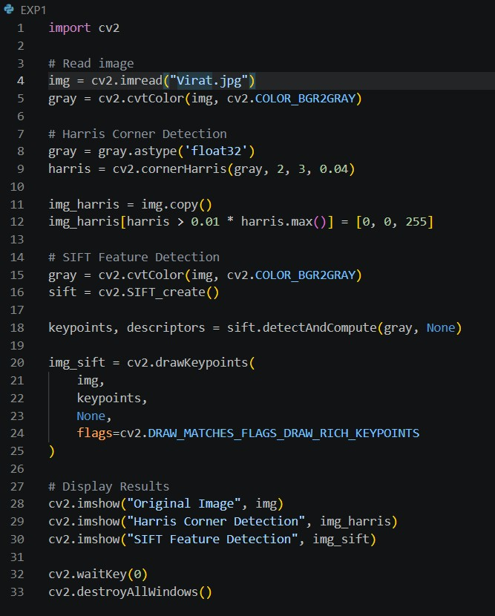

Input:



Output:

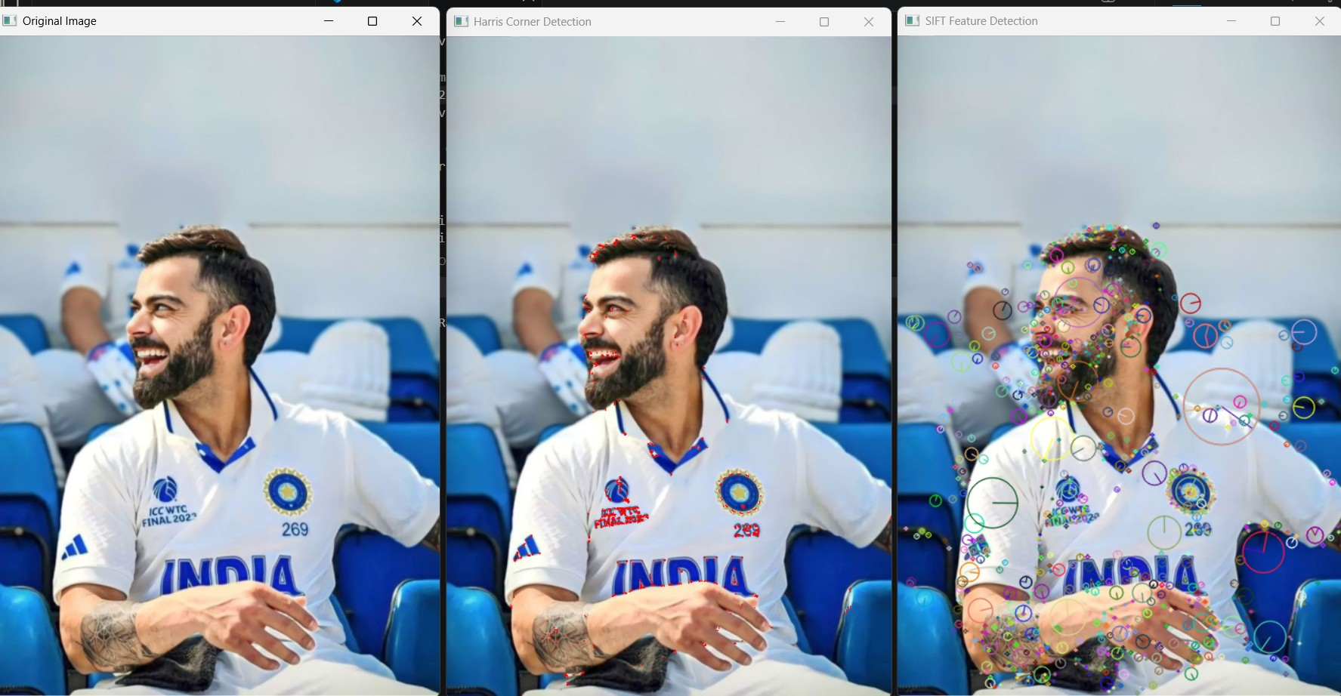

Observation:

Technique | Observation
Harris Corner Detection | D e te c ts stro n g c orn e r poin ts in th e im a ge .
SIFT Feature Detection | D e te c ts m a n y sta ble k e y po in ts w ith d e scripto rs su ita b le for m atch in g .

Performance Analysis:

Parameter | Harris | SIFT
Fe a tu re Q u a lity | G o od co rn e r de te ction | H igh - q u a lity distin ctive fe a tu re s
Ro bu stn e ss | Se n sitiv e to sca le ch a n ge s | Ro bu st to sc a le a n d rota tion
Re p e a ta bility | M ode ra te | H igh
Im a g e M a tch in g | Lim ite d | Exce lle n t
Co m pu ta tion a l Co st | Lo w | H igh e r

Output

- O rigin a l Im a ge

- H a rris C orn e r D e te ction O u tpu t

- SIF T F e atu re D e te c tio n O u tpu t

Result:

Th e e xpe rim e n t w a s su cce ssfully p erform e d to co m pa re Harris Corner Detection a n d SIFT Feature Extraction. H a rr is e ffic ie n tly de tec te d c orn e r po in ts b ut w a s le ss ro bu st to sca le va ria t ion s. S IF T d ete cte d sta ble a nd distin ctive k e y p oin ts w ith
fe a tu re d e scripto rs, p rov id in g b e tte r ro bu stn e ss, re pe a ta b ility , a n d su ita b ility for im a g e m a tc h in g a pp lica tion s. Th e re fo re , SIFT performs better than Harris for feature extraction and image matching, w h ile Harris is computationally simpler and suitable for corner detection tasks.

- Image Enhancement for Feature Detection

Conduct an experiment to evaluate the effect of image enhancement techniques such as histogram equalization and contrast adjustment on feature detection performance. Explain the importance of image enhancement in computer vision. Apply enhancement methods followed by feature detection using appropriate tools, document the

intermediate and final outputs clearly, and analyze how enhancement
influences feature visibility, detection accuracy, and reliability.

Aim:

To e va lu a te th e e ffe ct of im a ge e n h a n ce m e n t te ch n iq u e s su ch a s H isto gra m Eq u a liza tion a n d Co n tra st A dju stm e n t on fe a tu re de te c tio n pe rform a n ce a nd a n a lyz e th e ir in flue n c e on fe atu re visibility, d e te ction a c cu ra c y, a n d re lia bility .
Theory:

Im a ge en h a n c e m e nt is a p re pro ce ssin g te c h n iqu e u sed to im pro ve th e v isu a l qu a lity of a n im a ge be fo re p e rform in g co m pu te r v ision ta sk s. It e nh a n c e s im p ortan t im a ge de ta ils, m a k in g fe a tu re d e te ction m o re a cc u ra te a n d re lia ble .
H istog ra m E qu a liz a tion im p rov e s im a ge co n tra st by red istribu tin g th e in te n sity va lu e s o ve r th e e n tire ran g e , m a k in g h idde n fe a tu re s m ore visible .
C on tra st Ad ju stm e n t m o difie s th e b rig h tn e ss a n d c on tra st of an im a ge to im pro ve fe a tu re v isib ility , e spe c ia lly in lo w - c on tra st im a g es.
Afte r en h a n c em en t , fe a tu re de tec tio n a lg orithm s su c h a s O R B (O rie n te d FA ST a n d R ota te d B R IEF ) ca n id e n tify m o re sta ble a n d reliab le k e y poin ts, im pro vin g im a g e a n a ly sis a n d m a tc hin g p e rform an c e .
Algorithm:

  - Start th e p rog ra m .

  - Im po rt th e re qu ire d O p en C V libra ry.

  - R e a d the in pu t im a ge .

  - C on v e rt th e im a ge into g ra ysc a le .

  - Ap ply H isto gra m Equ a liz a tio n.

  - Ap ply Co n tra st A dju stm e n t.

  - D e te c t im ag e fe a tu re s u sin g th e O R B fe a tu re d ete cto r.

  - D ra w th e de te cte d k e y poin ts on th e e n h a nc e d im a ge .

  - D ispla y th e origin a l im a g e , e nh a n c e d im a ge s, a n d fe a tu re de te c tion re su lts.

  - C om p a re th e o u tpu ts a n d a n a lyze th e im p rov e m e n t.

  - Stop th e pro gra m .

Program:

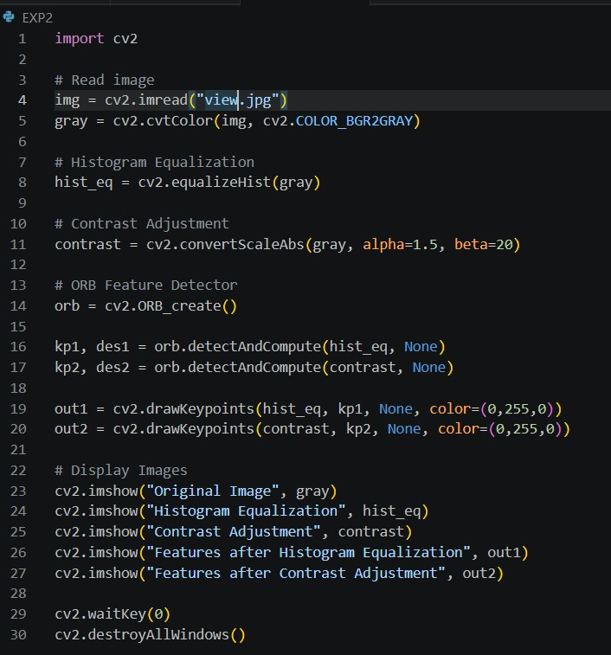

Input:



Output:

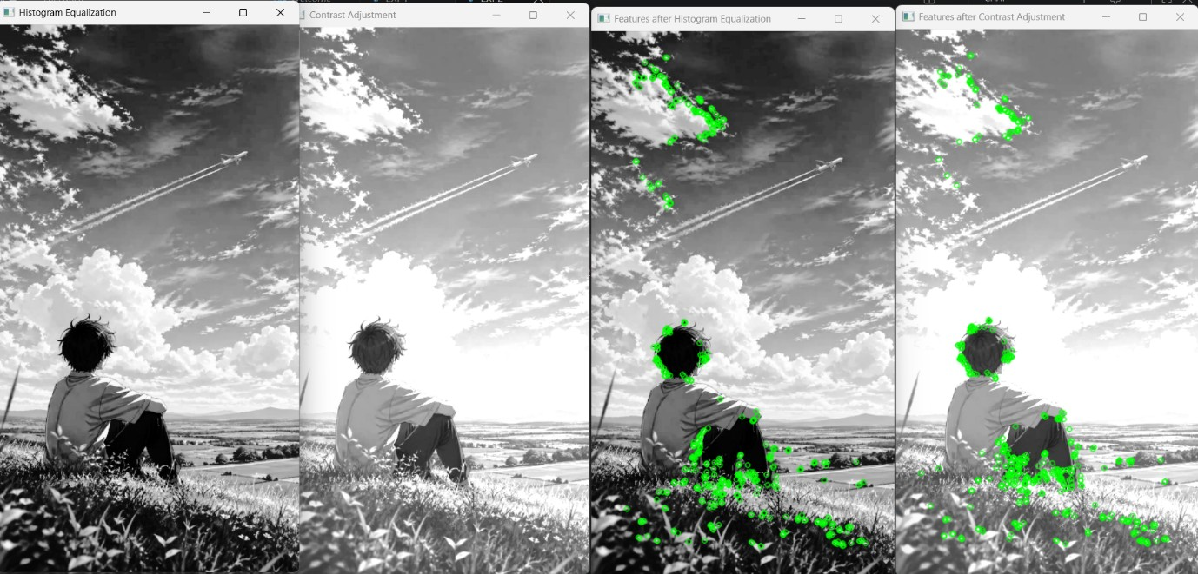

Intermediate Outputs:

- O rigin a l G ra y sca le Im a ge

- H istog ra m Eq u a lize d Im ag e

- C on tra st Ad ju ste d Im a g e

Final Outputs:

- Fe a tu res de te c te d a fte r H istogra m Eq u aliza tio n

- Fe a tu res de te c te d a fte r C on tra st Adju stm e n t

Observation:

Enhancement Technique | Observation
Histogram Equalization | Im p rov e d im a ge c on tra st a n d re v e a le d m ore im a ge de ta ils.
Contrast Adjustment | En h a n ce d brig h tn e ss a n d con tra st, m a k in g obje ct fe a tu re s cle a re r.
ORB Feature Detection | D e te cte d m o re re lia ble a n d sta ble k e y poin ts a fte r en h a n c em en t.

Analysis:

Parameter | Histogram Equalization | Contrast Adjustment
Fe a tu re V isib ility | H igh | H igh
D e te ction Acc u ra cy | Im p rov e d | Im p rov e d
Re lia b ility | G o od | G o od
Im a g e C on tra st | Sig nific a ntly Im p rov e d | M ode ra te ly Im p rov e d

Result:

Th e im a ge e n h a n ce m e n t te ch n iq u es im prove d im a g e qu a lity a n d in cre a se d th e n u m be r of d e te cte d fe a ture s. H istog ra m Equ a liz a tio n a n d C on tra st A dju stm en t provide d be tte r fe a tu re d ete ction th a n th e orig in a l im a g e .

- Multi-Scale Feature Detection Analysis
Design and implement an experiment to study feature detection at different image scales. Explain the concept of image scaling and scale-space representation in feature extraction. Apply feature
detection methods on images of varying resolutions using suitable
software/tools, document the detected features systematically, and analyze the effect of scale variations on feature stability, accuracy, and computational performance.

Aim:

To stu dy fe a tu re de tec tio n a t d iffe re n t im a g e sc a le s a n d a n a ly ze th e e ffe ct of sca le v a ria tion s o n fe a tu re sta b ility , a ccu rac y, a n d co m pu ta tion a l pe rform a n ce .

Theory:

Im a ge sc a lin g is th e pro ce ss o f re siz in g a n im a ge to d iffe re n t reso lu tion s. Sc a le- sp a ce re prese n tation a llow s fe atu re s to be de te cte d c on sisten t ly a cro ss m u ltip le im a g e siz e s. SIFT ( Sc ale - In va ria n t F e a tu re T ra n sform ) de te c ts stab le k e yp oin ts th a t a re in v a ria n t to im a g e sca le , m a k in g it su ita b le for fea tu re e xtra c tio n from im a ge s of d iffe re n t re solu tio n s.

Algorithm:

  - Start th e p rog ra m .

  - Im po rt th e re qu ire d O p en C V libra ry.

  - R e a d the in pu t im a ge .

  - C on v e rt th e im a ge into g ra ysc a le .

  - R e siz e th e im a g e to diffe re n t sca le s ( 1 .0 , 0 .75 , an d 0 . 5 ).

  - Ap ply SIFT fe a tu re d e te ction to e a ch sc a le d im ag e .

  - D ra w th e de te cte d k e y po in ts.

  - D ispla y th e fe a tu re d ete ctio n re su lts fo r e a c h sca le .

  - C om p a re th e d e te cte d fe a tu re s.

  - Stop th e pro gra m .

Program:

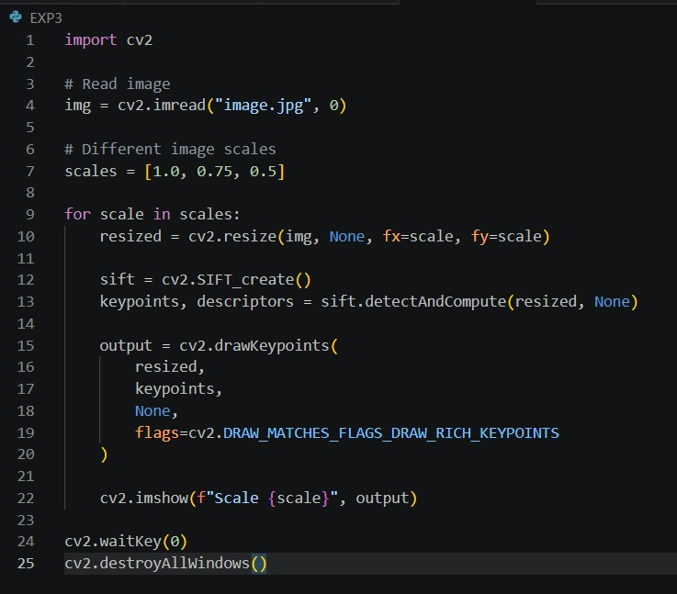

Input:
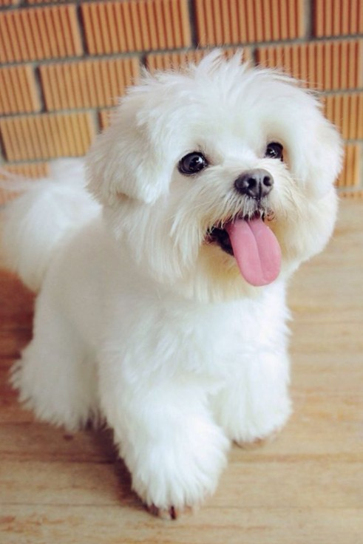

Output:

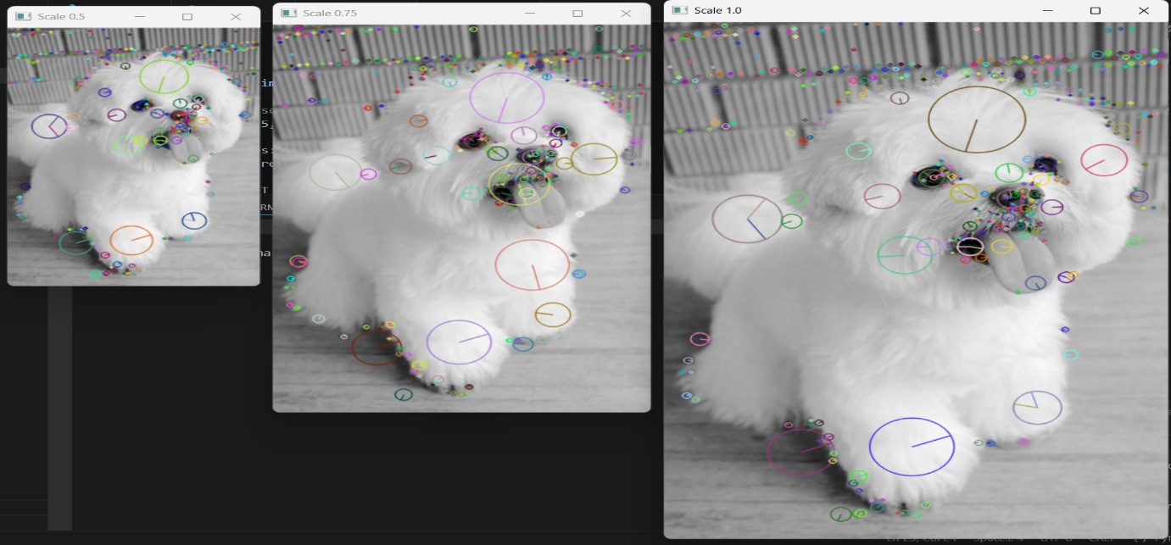

Intermediate Outputs:

1 . O rigin a l Im a ge
2 . Im a ge re size d | to | 1.0 scale
3 . Im a ge re size d | to | 0.75 scale
4 . Im a ge re size d | to | 0.5 scale

Final Output:

Fe a tu re de te c tion re su lts for a ll th re e im a g e sca le s.

Observation:

Observation
Image Scale


1.0 | M a xim u m n u m be r of k e y po in ts d e te cte d .
0 .75 | S ligh t re du ction in k e y p oints.
0 .5 | F e w e r k e y p oin ts de te c te d d u e to lo w er re so lu tion .

Analysis:

Parameter | Observation
Fe a tu re S ta bility | SIFT de te c ts sta b le ke y p oin ts ac ross differe nt sca le s.
Acc u ra cy | H igh e r a t la rge r im a ge sc a le s.
Co m pu ta tion a l Pe rfo rm a n ce | Fa ste r for sm a lle r im a ge s du e to red u ce d im a ge size .

Result:

Th e e xpe rim e n t w a s su cc e ssfu lly p e rform e d. SIFT de te cte d sta ble fe a tu re s a t diffe re n t im a ge sc ale s, sh ow in g go od sca le in v a ria n ce w h ile m a in tain in g reliab le fe a tu re d e te ction .

- Comparative Analysis of Image Filtering Techniques

Conduct an experiment to compare different image filtering techniques, such as Mean, Gaussian, and Median filtering, for preprocessing. Explain the theoretical concepts and objectives of each filtering method. Implement the filters using appropriate tools/software, document the processed images and observations
clearly, and analyse their effectiveness in noise reduction while
preserving important image features for subsequent feature detection.

Aim:

To c om pa re M e a n , G a u ssia n , a n d M e dia n f ilte rin g te ch n iqu e s fo r im a g e prep roc e ssin g a n d an a ly se th e ir e ffe c tive n e ss in n o ise re du c tio n w h ile prese rvin g im p ortan t im a ge fe a tu re s.
Theory:

Im a ge filte r in g is a p re pro ce ssin g te ch n iq u e use d to re m o ve n o ise a n d im p rov e im a g e qu a lity be fore fe a tu re de te c tion .
- Mean Filter: R e pla ce s e a ch p ixe l w ith th e a v e ra ge va lu e of its n e igh b ou rin g pixe ls. It sm o oth s th e im a ge b u t m a y blu r e d ge s.
- Gaussian Filter: U se s a G a u ssia n fu n ctio n to sm ooth th e im a ge w h ile prese rvin g e dg e s be tte r th a n th e M e a n f ilte r.
- Median Filter: R e pla ce s e a ch pixe l w ith the m e d ia n va lu e of its n e ig hb ou rin g p ixe ls. It is h ig h ly e ffe c tiv e in rem ovin g sa lt- a n d- p e pp er n oise w h ile pre se rv in g e d ge s.

Algorithm:

  - Start th e p rog ra m .

  - Im po rt th e re qu ire d O p en C V libra ry.

  - R e a d the in pu t im a ge .

  - Ap ply th e M e a n filte r .

  - Ap ply th e G a ussia n filte r.

  - Ap ply th e M e dia n filte r.

  - D ispla y th e origin a l a n d filte re d im a ge s.

  - C om p a re th e filte rin g re su lts.

  - Stop th e pro gra m .

Program:

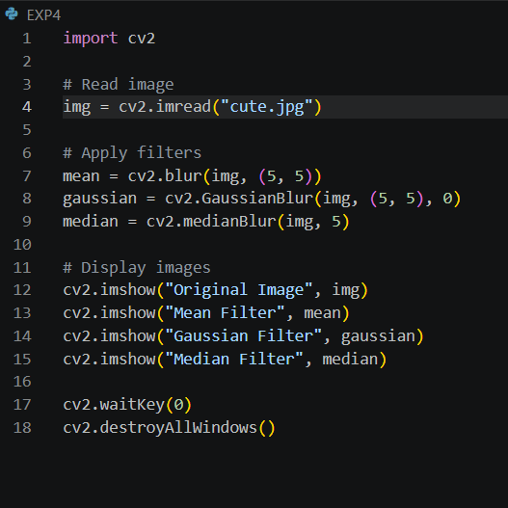

Input:

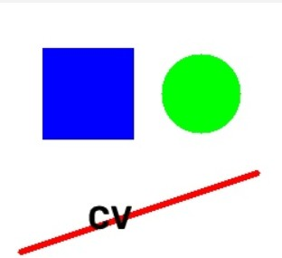

Output:

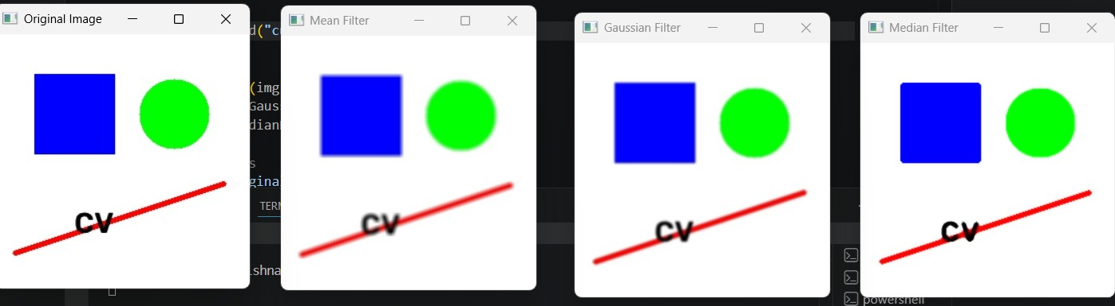

Intermediate Outputs:

- O rigin a l Im a ge

- M e a n Filte re d Im a g e

- G a u ssia n Filte re d Im a ge

- M e dia n Filte red Im a ge

Final Output:

C om p a rison of M e a n , G a u ssia n , a n d M e d ia n filtere d im ag e s.

Observation:

Filter | Observation
M e an Filte r | Sm o oth s th e im a g e bu t sligh tly blu rs e dg e s.
G a u ssia n Filte r | R e du c es n oise w h ile p re se rvin g im ag e de tails.

M e dia n Filte r | R e m ov e s sa lt- a n d- pe p pe r n o ise a n d pre se rv e s e dg es e ffe ctive ly.

Analysis:

Parameter | Mean | Gaussian | Median
N oise Re d u ction | G o od | B e tte r | Be st for sa lt- a n d- pe p pe r n o ise
Edg e Pre se rv a tio n | Low | G ood | Ve ry G ood
Fe a tu re P re se rva tion | M ode rate | G ood | Be st

Result:

Th e e xpe rim e n t w a s su cce ssfully pe rfo rm e d. Am o n g th e th re e filte rs, th e M e dia n filte r p re se rve d im a ge fe a tu re s w h ile e ffe c tiv ely re du cin g n oise , m a k in g it su itab le fo r prep roc e ssin g be fore fe a tu re d e te ction .

- Complete Object Detection Workflow

Design and perform an experiment to develop an object detection workflow incorporating image preprocessing, edge detection, feature extraction, and shape detection. Explain the purpose and interaction of each processing stage in the workflow. Implement the complete pipeline using suitable software/tools, document the outputs at every
stage systematically, and analyse the effectiveness of the integrated
approach in achieving accurate and reliable object detection under different image conditions.

Aim:

To de ve lo p a n o bjec t de te c tio n w ork flow in corporatin g im a g e p re proce ssing , e dg e de te c tio n , fe a tu re e xtrac tio n , a n d sh a p e de te c tio n a n d a n a lyz e its e ffe c tiv en e ss un d e r d iffe re n t im a ge c on ditio n s.
Theory:

O b je ct de te c tio n is a c om p ute r v isio n te c hn iqu e u se d to id e n tify a n d loc ate ob je cts in a n im a ge .
- Image Preprocessing: Im prov e s im a g e qu a lity a n d re m ov e s n oise .

- Edge Detection: D e te c ts o bje c t bo u n da rie s usin g the Ca n n y e dg e de te c tor.

- Feature Extraction: Extra c ts im porta n t im a g e fe a tu re s u sin g O R B .

- Shape Detection: D e te cts obje ct sh a p e s u sin g con tou r d e te ction .

Th e se sta ge s w ork tog eth e r to im p rov e th e a cc u ra cy a n d re lia bility o f ob je ct de tec tio n .
Algorithm:

  - Start th e p rog ra m .

  - Im po rt th e re qu ire d O p en C V libra ry.

  - R e a d the in pu t im a ge .

  - C on v e rt th e im a ge into g ra ysc a le .

  - Ap ply G a u ssia n Blu r for p re proce ssing .

  - Pe rform C a n n y Ed ge D e tec tio n .

  - D e te c t O R B fea ture k e y p oin ts.

  - D e te c t o bje c t c on tou rs (sh a p e de te c tio n).

  - D ra w k e y po in ts a n d co n tou rs o n th e im a ge .

  - D ispla y th e ou tp u ts of e a ch sta g e . 11. Stop th e pro gra m .
Program:

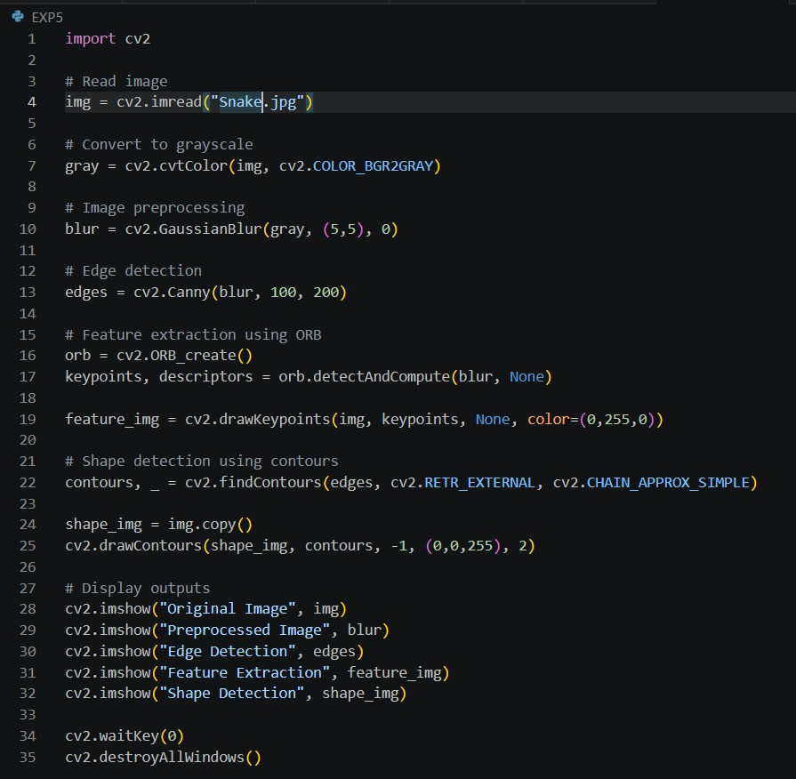

Input:



Output:

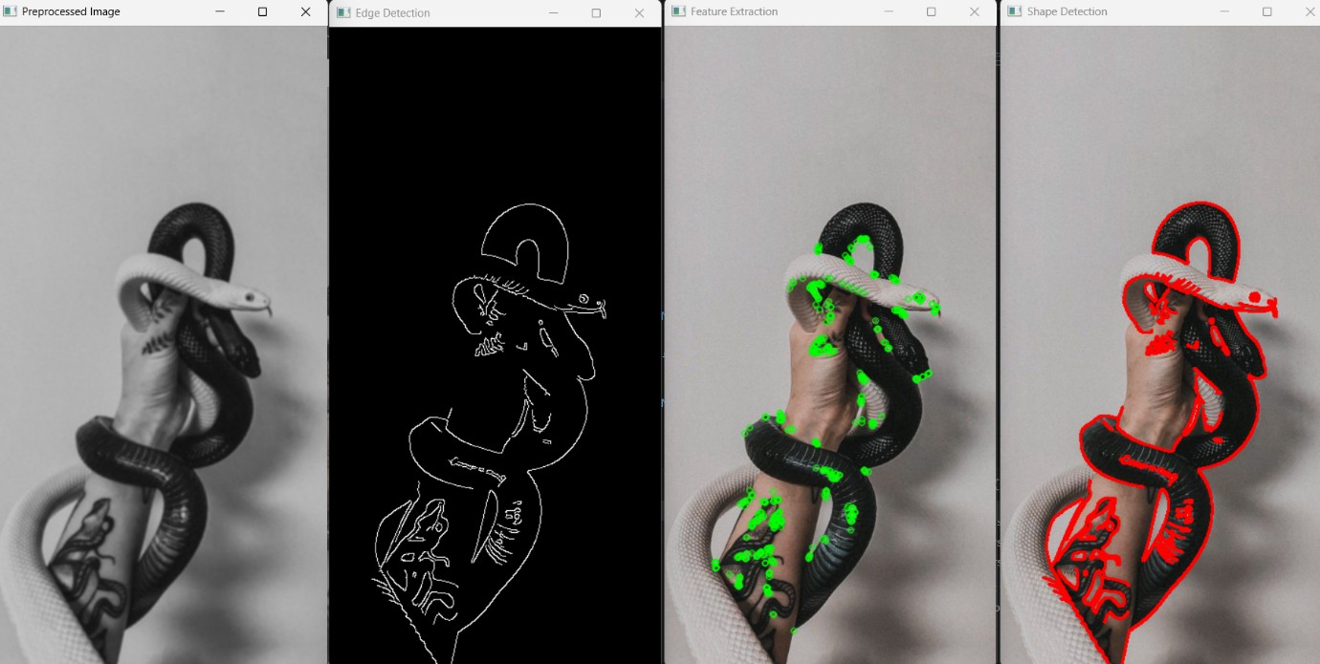

Intermediate Outputs:

- O rigin a l Im a ge

- Pre- p roc e sse d Im a ge

- Ed ge D e te ction O u tpu t

- Fe a tu re Extra c tio n O u tp u t

Final Output:

Sh a p e D e te c tion (C on tou rs D ete cte d )

Observation:

Stage | Observation
Pre proce ssing | Re d u ce d im a ge n o ise .
Edg e  D e te ction | D e te cte d ob je ct bo u n da rie s.
Fe a tu re  Extra c tio n | Id e n tifie d im p ortan t k e y p oin ts.

Sh a pe  D e te ction | Su cc e ssfu lly de tec te d obje ct con to u rs.


Analysis:

Parameter | Observation
N oise  Re d u ction | Im p rov e d a fte r prep roc e ssin g.
Edg e  Acc u ra cy | Cle a r o bje c t b ou n da rie s de te c te d.
Fe a tu re  D e te ction | Sta ble k e y po in ts e xtra cte d .
O bje c t  D e te ction | Acc u ra te c on tou r de te c tio n u n de r d iffe re n t im a ge c on d itio n s.

Result:

Th e co m ple te o bje c t d e te ction w o rk flow w a s su c ce ssfu lly im p le m e n te d . T h e prep roc e ssin g, e dg e de te c tion , fe a tu re e xtra c tio n , a n d sh a p e de te ction sta g e s w ork e d tog e th e r to a ch iev e a cc u ra te a n d re lia ble o bje c t de tec tio n .

